SECT ZG629 T: Dissertation

context and component dependency injection

Dissertation work carried out at

Cognizant Technology Solutions

by

Arun Raj

2013HZ78275

Dissertation submitted for the partial fulfillment of
M.S. Software Engineering Degree
Under the Supervision of
C K Mohammed Navas
Architect-Technology
Coimbatore



BIRLA INSTITUTE OF TECHNOLOGY & SCIENCE
PILANI (RAJASTHAN)
Dec., 2015

BIRLA INSTITUE OF TECHNOLOGY AND SCIENCE, PILANI



CERTIFICATE

This is to certify that the Dissertation entitled “Context and Component Dependency Injection” submitted by Arun Raj, BITS ID-No. for the partial fulfillment of the requirements of M.S. Software Engineering degree of BITS, Pilani embodies the work done by him under my supervision.

C K Mohammed Navas

Signature of the Guide/Supervisor

Name : C K Mohammed Navas
Designation : Architect - Technology
Location : Coimbatore
Date : 23 November 2015

ABSTRACT

Dissertation Title : Context and Component Dependency Injection
Name of Supervisor/Guide : C K Mohammed Navas
Name of the student : Arun Raj
BITS ID. No. : 2013HZ78275
Semester : I semester 2015-2016

Problem Statement:
The most critical part of any enterprise software is the uptime of the application. When it comes to distributed and scalable environments the task is tedious. For this purpose all the frequently changed segments such as queries, static texts, passwords, location of some important files are externalized. The work becomes more tedious when the files are moved from one environment to another which is the most error prone area. Even though these parts are externalized, a server restart is required to make it effective and make it available in the application which is costly and not acceptable for frequent changes and at present there is no tool available in the market.

Problem Solution:
Context and Component Dependency Injection is a framework based on spring that allows the hot deployment of externally deployed files without the need of server restart. The framework uses keys to resolve the corresponding values from the cache or database. The framework works with the help of a database and a caching framework for the fast accessibility of the data and to minimize the server hits. The framework also has a built in capability to configure multiple environments in a single entry there by reducing the effort of moving the files and cross verification time. The framework can also act as a theme engine that can display different theme depend on the environment of the application.

Features:
- Hot deployment of external dependency
- High speed and high scalability
- Guaranteed 100% server uptime for external file changes
- Most useful in distributed applications
- Can act as a theme engine
- Can be used in Java classes as well as JSPs
- Can be used as placeholders in spring configuration file
- Can be implemented in any spring projects easily

Signature of student Signature of supervisor

Name: Arun Raj Name of Supervisor:C K Mohammad Navas

Date: 23 November 2015 Designation: Architect - Technology

Location : Coimbatore

Acknowledgement

I take this opportunity to sincerely thank my project guide Mr. C K Mohammed Navas and my co-guide Mr. Vivekanandan Elango for providing me guidance even during the tough times of his project and in bringing out the idea for dissertation and insight & advice to aid me in implementing this idea.

Proposed Activities

Table 1: Status table
Stage | Purpose | Activities | Status | Deliverable
Stage 1 | - Define Scope of Dissertation  - Define Requirements | Providing the Project proposal with project description. | 100% | Preliminary Report
Stage 2 | - Propose Solution  - Detailed design for the proposed Solution | Proposed Solution  - High level design  - Technical Requirement – Software & Hardware for development and production implementation | 100% | Mid Review report
Stage 3 | - QA and Documentation | Testing  - Development & Unit testing  - Functional testing & assessment | 100% | Final review Report
Stage 3 | - QA and Documentation | Define future extensibility opportunities | 100% | Final review Report

1 Software Requirement Specification

1.1 Functional Requirements
Following are the detailed functional requirements for the system:

1.1.1 Module

1.1.1 .1 System Requirement

 | Resolver | Description | Sample Key | Sample Value
1 | Property | Resolve the property [environment independent] | app_users | User1,user2,user3
2 | Environment | Resolve the environment property [environment dependent] | db_username | [dev: testuser][sit:situser][uat: uatuser][prod:testproduser]
3 | Verbiage | Resolve the html verbiage property [environment dependent] | label/home/dropdown | [dev:<select id="homeFront"><option value="CQ">Create Quote</option><option value="MQ">Modify Quote</option><option value="DQ">Delete Quote</option></select>][sit:<label>Enter UserName</label><input type="text">]
4 | Validator | Resolve the regex validator for the key | emailValidator | ^[a-zA-Z0-9.!#$%&'*+/=?^_`{|}~-]+@[a-zA-Z0-9](?:[a-zA-Z0-9-]{0,61}[a-zA-Z0-9])?(?:\.[a-zA-Z0-9](?:[a-zA-Z0-9-]{0,61}[a-zA-Z0-9])?)*$
5 | Gateway | Resolve the action gateway for the spring integration key | loginAction | loginGateway

1.2 Non Functional Requirement

- The environment dependent variables should be parsed and corresponding value is returned
- The environment entry must be set in server so that hot deployment is easy
- The cache must be cleared after every property change

1.3 Use Case Diagrams

CCDI Environment entry use case diagram

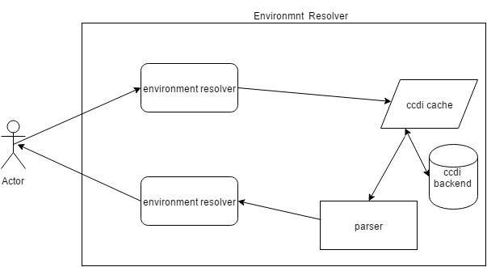

CCDI Property resolver use case diagram

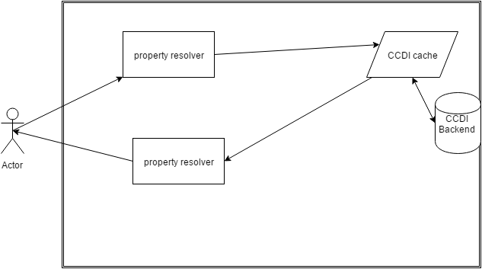

CCDI Theme Engine use case diagram
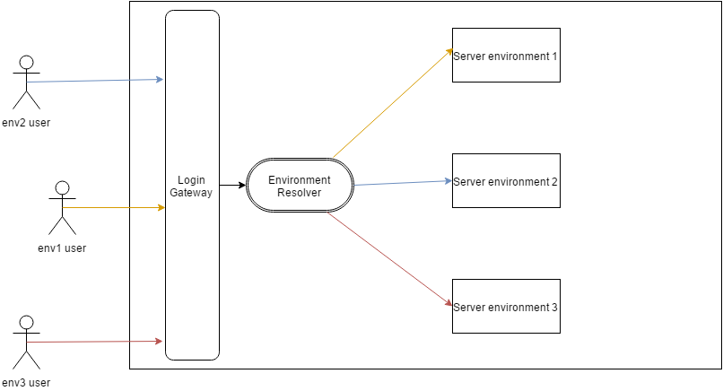

1.4 Proposed Solution

CCDI [Context and Component Dependency Injection] is a spring based key-value pair framework designed to take the file externalization to the next level. This is a key-value pair solution where the user’s entry (key) depends on what type of resolver it is e.g. property / environment gets resolved from a service hit to cache or db. CCDI uses tightly coupled cache-database architecture so that the requests first hit the cache and if not found redirects to the database. The routing algorithm is specified using Spring Integration.

CCDI acts as a horizontal layer across the application for easy component resolving.

Below are some examples of external files placed in the server for application
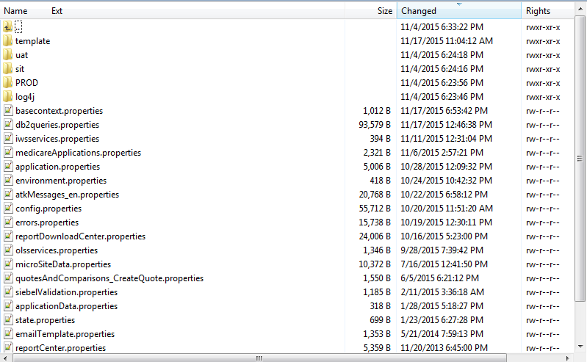
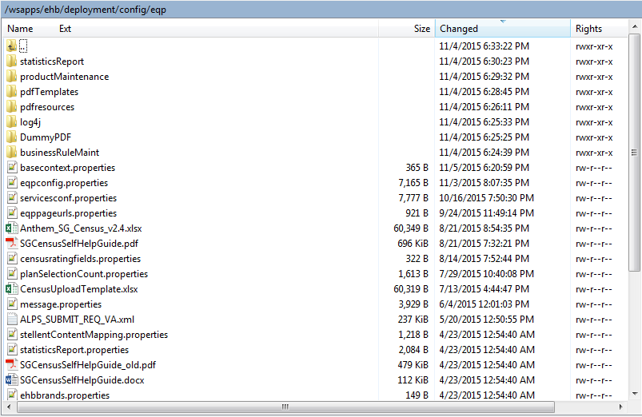
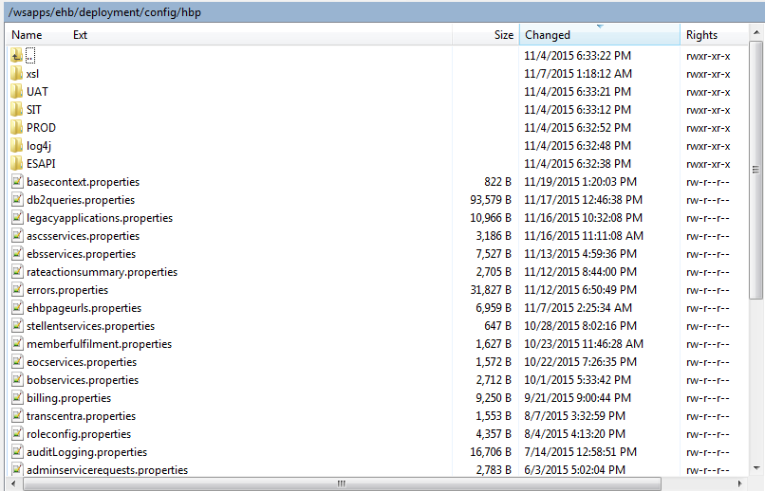

Moving the files across various environments even for a single file change is tedious and error prone. By the use of CCDI there is no need of external property files and themes. The data is configured in database and can be easily traversed to any environment. Different property configurations for different environments can be specified in a single database entry and is hot deployable.

1.5 Technical Requirements

1.5.1 Software Requirement For End Users

Operating System : Windows/Linux/Mac
Others : Chrome/Mozilla/IE/Opera

1.5.2 Software Used In Development

Operating System : Windows 8
Languages : Java1.6, JavaScript, JQuery
Database : Oracle 11g xe
Web server : IBM Websphere 8.5
Application server : IBM Websphere 8.5
Other Software : Eclipse Luna, IBM Dynacache

1.6 Solution Architecture

Proposed Solution Architecture
Request Transformer
CCDI DB
Response Transformer

Application

Key Builder

CCDI CACHE

Value

1.7 Module Interaction Flow

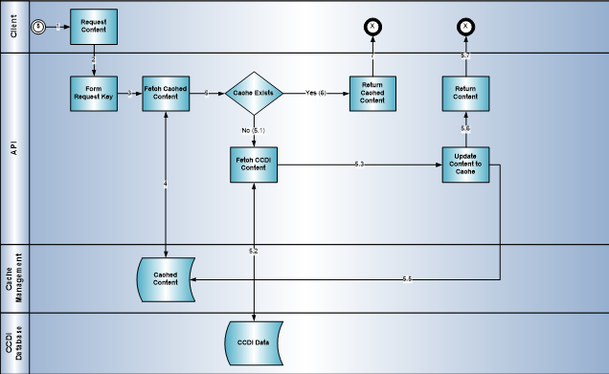

1.8 Technical Design

1.8.1 CCDI Service Integration Diagram

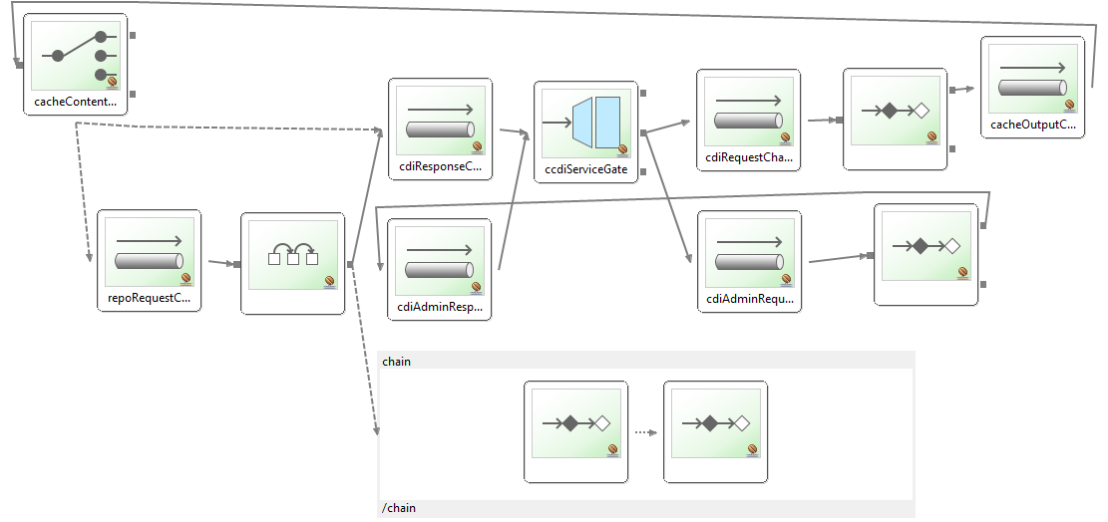

1.8.2 Sequence Diagram
